**Experiment No.9**

**Aim:**  Edit/compile/run a program to implement quick sort/ merge sort/ bubble sort.

**Program A: QUICK SORT ALGORITHM:**

def partition(array, low, high):  
 pivot = array[high]  
 i = low - 1  
 for j in range(low, high):  
 if array[j] <= pivot:  
 i = i + 1  
 (array[i], array[j]) = (array[j], array[i])  
 (array[i+1], array[high]) = (array[high], array[i+1])  
 return i+1  
  
def quickSort(array, low, high):  
 if low < high:  
 pi = partition(array, low, high)  
 quickSort(array, low, pi-1)  
 quickSort(array, pi+1, high)  
  
data = [28,9,4,2,24,8]  
print("Unsorted array is as follows: ")  
print(data)  
size = len(data)  
quickSort(data, 0, size-1)  
print('Sorted array in Ascending order is as follows: ')  
print(data)

**Output:** 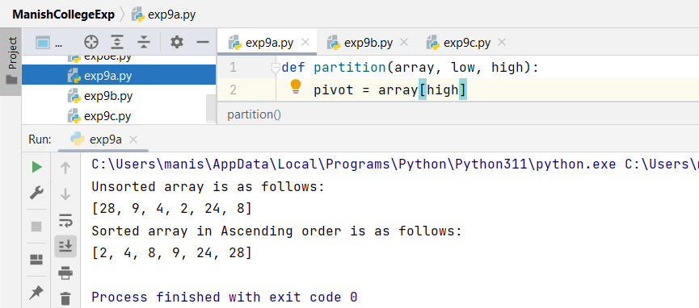

**Program B: MERGE SORT ALGORITHM**

def mergeSort(arr):  
 if len(arr) > 1:  
 mid = len(arr)//2  
 L=arr[:mid]  
 R=arr[mid:]  
 mergeSort(L)  
 mergeSort(R)  
 i=j=k=0  
 while i<len(L) and j<len(R):  
 if L[i] <= R[j]:  
 arr[k] = L[i]  
 i+=1  
 else:  
 arr[k] = R[j]  
 j+=1  
 k+=1  
  
 while i<len(L):  
 arr[k] = L[i]  
 i+=1  
 k+=1  
  
 while j<len(R):  
 arr[k] = R[j]  
 j+=1  
 k+=1  
  
  
def printList(arr):  
 for i in range(len(arr)):  
 print(arr[i], end=" ")  
 print()  
  
if __name__ == '__main__':  
 arr=[248,904,477,289,245,]  
 print("Given array is: ", end="\n")  
 printList(arr)  
 mergeSort(arr)  
 print("Sorted array is: ", end="\n")  
 printList(arr)

**Output:**

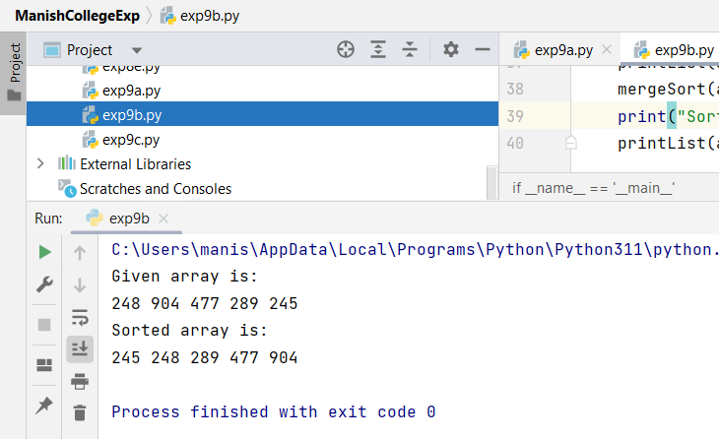

**Program C:** **BUBBLE SORT ALGORITHM**

def bubbleSort(arr):  
 n =len(arr)  
 for i in range(n):  
 swapped = False  
  
 for j in range(0,n-i-1):  
 if arr[j]>arr[j+1]:  
 arr[j], arr[j+1] = arr[j+1], arr[j]  
 swapped = True  
 if(swapped == False):  
 break  
  
if __name__ == "__main__":  
 arr=[951, 753, 654, 258, 359,751,153]  
 print("Given array is: ", end="\n")  
 print(arr)  
  
 bubbleSort(arr)  
  
 print("Sorted Array is: ")  
 for i in range(len(arr)):  
 print("%d" %arr[i], end=" ")

**Output:**

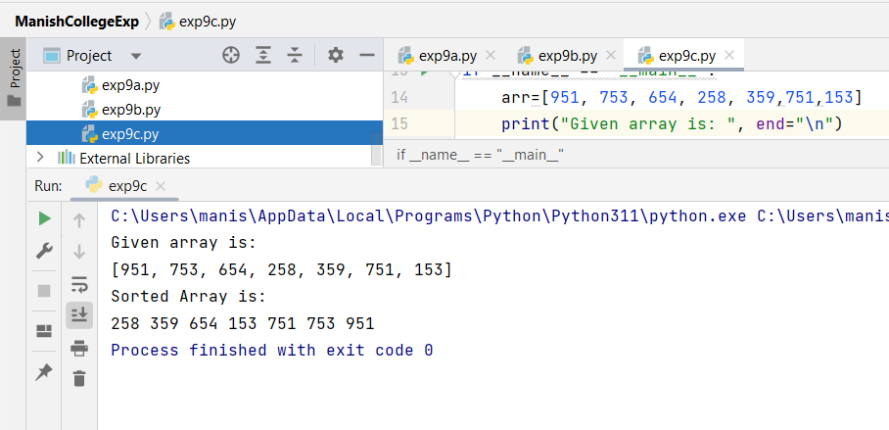

|  |  |  |  |
| --- | --- | --- | --- |
| **Practical Performance**  **(4)** | **Writeup & Oral**  **(4)** | **Attendance**  **(2)** | **Total**  **(10)** |
|  |  |  |  |